ERSA Race Format & Rules
Version 1.2.1
20/06/16
Note: These rules are for non FAI sanctioned events

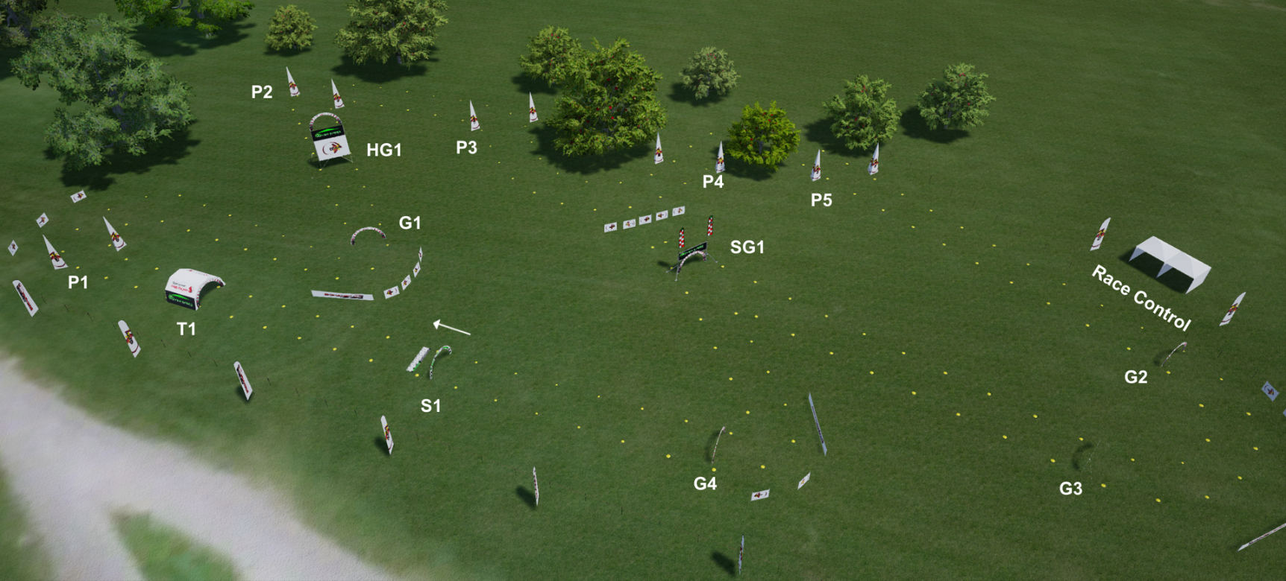

CONTENTS
- GENERAL SPECIFICATIONS OF THE FPV RACING MODEL
1.1. Weight and size of the model
1.2. Motorization
1.3. Propellers
1.4. Other equipment
1.5. Identification LED’s
1.6. Frequencies
2. RACING CIRCUIT
2.1. Racing circuit size
2.2. Safety
2.3. Racing circuit design
2.4. Air gates
2.5. Obstacles
2.6. Start line
2.7. Other points
3. RACE FORMAT
3.1. Qualifying
3.2. Qualification Formats
3.4. Qualifying by laps
3.5. Time based Qualifying
3.6. Finals
3.7. Knock out finals
3.8. Finals for all
3.9. Final race
3.10. Infringements and penalties

1.GENERAL SPECIFICATIONS OF THE FPV RACING MODEL
1.1. Weight and size of the model
The total weight of the model including all equipment necessary for flight (including batteries) shall not exceed 1 kg. Distance between axes of the engines shall be less than 330 mm and more than 170 mm. This distance is measured on the diagonal of the engines’ axes.
1.2. Motorization
Only electric motors with a maximum voltage of 17.0 volts (4S) are allowed.
1.3. Propellers
Maximum diameter: 7 inches (17.78 cm). Full metal propellers are forbidden.
1.4. Other equipment
The model must be equipped with a fail-safe device, the triggering of which stops the motorization in the event of control signal loss. The failsafe must trigger within 3 seconds of a signal loss.
It is forbidden to use a pre-programmed manoeuvring device (GPS Guidance). Any system for automatic positioning and/or path rectification in longitude, latitude or height is forbidden e.g. Sonar.
The use of self-levelling flight modes is permitted.
1.5. Identification LED’s
All air craft must be fitted with rear and front facing LED’s. This is to aid safety and to improve the spectator experience. LED’s on ESC’s, Flight Control Boards etc. will not be sufficient. It is recommended but not compulsory to use colour selectable LED’s.
1.6. Frequencies
Frequencies used can only be those authorised in the country in which the contest is organised. Ensuing associated emission power limitations should be respected. This concerns the radio control system of the model as well as the video transmission device of the on-board camera.
VTX frequencies and power output levels will be determined by the organiser before the event and competitors will be informed no less than 10 days before the competition.
The use of digital VTX systems is permitted in general but the final decision is that of the individual organiser.

2. RACING CIRCUIT
2.1. Racing circuit size
The racing circuit must have a minimum developed size of: - 250 m for an outdoor field. - 80 m for an indoor circuit.
If the racing circuit includes passages with a risk of problems from propagation of high frequency waves (such as trees or walls), the organiser will ensure that the video link has sufficient quality for safe piloting with a standard transmitter.
The recommended length of an outdoor race course is between 350 m and 500 m
2.2. Safety
A safety line for demarcation of the flight area must be in place and easily recognisable. The minimum distance between the safety line and the active flight area is 30 meters. Where the distance is less than 30 meters a safety net must be used with a minimum height of 3 meters. There must be a minimum gap of 3 meters between the safety net and the safety line.
A safety marshal will have responsibility to ensure no persons are on any part of the active flight area. Should a person or animal stray onto the active flight area the marshal shall give a warning via air-horn or whistle. Upon hearing this pilots must land their craft as quickly and safely as possible.
2.3. Racing circuit design
The organiser is encouraged to demonstrate creativity. They may take advantage of the specifics of the site. They must however, respect the following rules:
The racing circuit must be designed in order to prevent accidental diversions from the racing area. Clear markings on the ground and the correct use of pylons and flags will ensure that pilots can easily follow the track without becoming confused.
2.4. Air-gates
The racing circuit must include at least 3 air-gates.
Recommended air-gate sizes are: - Width: 3.0 m maximum 1.6 m minimum -Height: 1.9 m maximum, 1.4 m minimum.
The air gate must contrast with the background and be perfectly visible with a standard FPV video device at a 30 metre distance.
2.5. Obstacles
Obstacles include but are not limited to:
Pylons, High gates, Split “S” gates, Tunnels.
Obstacles should be placed in such a way that pilots have enough time and distance to line up for the obstacle and have time and distance to recover from the obstacle. Any obstacle contrast with the background and be clearly visible with standard FPV devices at a 30 metre distance.
2.6. Start line
The start line will be a line perpendicular to the axis of the initial racing circuit trajectory. This start line is not necessarily placed on the circuit track. All models will be placed on the start line or on a grid pattern (Formula 1 type start) and spaced a minimum of 0.4 metres in every direction.
The start line must be flat and level with a tolerance of no more than 5 degrees. No obstacle or turn can be placed before a distance of 30 metres after the start line. The start must be in a straight line. A marker should be placed 30 meters from the start line, to aid in decisions of restarts.
2.7. Other points
The design of a race track can be shared and advertised at the organisers will. The use of simulators to promote an up-coming event is also permitted.
The organiser must release full details of the specifics of an event, either directly to the competitors or publicly, no less than 10 days before the event (recommended time is 3 weeks) Organisers should include as much information as possible.
The details should include: What VTX frequencies are to be used, any special technical requirements for the air-craft, schedule of the event, what facilities are available such as battery charging, catering etc.
3. RACE FORMAT
3.1. Qualifying
○ The minimum number of competing pilots is 32.
○ Competitors will have a ​ minimum of four qualifying rounds​, spread over the period of the event in which to score points that will be used to calculate their qualifying position.
○ The lowest scoring round for each competitor will not be counted towards final standings.
○ To maximise the number of heats in a competition and to simplify the heats, it is recommended that competitors will remain in the same group and use the same video frequencies throughout the qualifying stages.
○ Pilots will be placed into race groups of 4-8 competitors (dependant on the event) ​ and each race group will be ​ numbered A, B, C etc. Pilots should remember and listen for their race group being called to race so that they are ready in plenty of time for the start of their race.
○ Pilots must be at Race Control in plenty of time for their race. If a pilot is late they will be given 90 seconds warning and disqualified from that heat if they fail to arrive after the 90 seconds. This includes pilots who experience technical difficulties.
○ At some events a judge will be provided, however where this is not possible, pilots in the next heat to race will act as judges for the pilots in the current race. Pilots on the same team cannot judge for each other.
Note: for official qualifying events or official finals the judge must be supplied by the organiser and be properly qualified and accredited by ERSA
○ Pilots who have finished a race must only recover their aircraft when told it is safe to do so by a race official. Pilots should power off their aircraft as soon as possible.

3.2. Qualification Formats
ERSA allow for 2 popular qualification formats “Laps” & “Timed”. The organiser must decide prior to the event which of the 2 formats are to be used and communicate this to the registered pilots not less than 10 days before the event.
3.4. Qualifying by laps
○ Each heat will last ​ 2 minutes​, during which competitors will race to complete as many laps as they can in that time.
○ Every lap completed will equate to 1 point, which will be added to their total score.
○ If a pilot crashes before the end of the race and cannot recover, all completed laps will still be added to their total score.
○ When the 2-minute timer is up the pilot may complete the lap they are currently on and this will count towards their score for that heat. A maximum of 30 seconds is allowed to complete this final lap.
○ The pilot finishing 1st will receive 1 bonus point.
○ At the end of the qualifying stage, all pilots will be sorted by the number of laps they completed. In the event of a tie, the pilot with the fastest lap time will determine who is first.
3.5. Time based Qualifying
○ Each heat will consist of 3 or more laps which will be timed using ERSA approved timing equipment.
○ The pilot must complete at least 3 consecutive laps and either:
i) The fastest lap of any consecutive 3 laps completed will become the score for that Heat and added to the pilot’s tally or
ii) The total time taken to complete 2-4 fastest consecutive laps will become the score for that Heat and added to the pilot’s tally
* Note: organiser must decide which scoring system is to be used and how many laps to score, and announce this prior to the event.
○ The Final standings will be determined by the lowest combined time of each pilot.
3.6. Finals
ERSA Rules allow for 2 types of finals. The first takes the form of traditional knock out stages which include ¼ and semi-finals followed by a final race to determine the winner of the competition. The second dispenses with knockout stages and instead has a final for every competitor.
3.7. Knock out finals
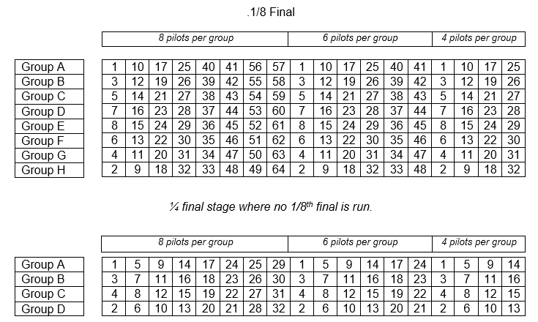
The elimination stage is either composed of: -1/8th final round (8 groups), - followed by the ¼ final round (4 groups) where the competition is of sufficient size, or straight to a ¼ final round - and then followed by the semi-final round (2 groups) and the final race.

The provisional ranking established at the end of the qualifying rounds will be used as follows to compose the groups and the order in each group according to the established number of pilots per group and depending whether the first elimination round is the 1/8th final round or the 1/4th round.
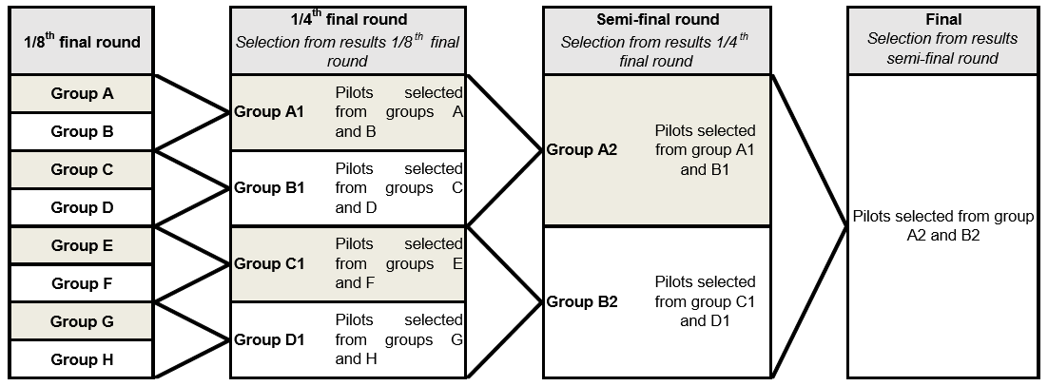

3.8. Finals for all
○ Pilots will be placed into groups of 4-8 pilots (dependant on the event) based on their position on the final standings table. The top finishers will make up the “Group A Final” the next best “Group B final” etc. for example in an event with 6 pilots per heat, pilots 1-6 will make up the “Group A Final” pilots 7-12 will make up the “Group B Final” and so on.
○ Finals will be run starting with the bottom final first and finishing with “Group A Final”
○ Each group final is in essence a final in its own right, however, it is the group A final that determines the overall winner of the competition.
3.9. Final race
○ Finals will be run over 4-6 laps with the winner being the first pilot to complete the number of required laps. Podium places will be decided on finishing positions.
3.10. Finishing positions
During the knockout stages, there may be times where the finishing position of 2 crashed pilots needs to be determined. In these cases, the pilots who completed the most laps is ahead of their competitor, it is not determined by who crashes first. For example, in a contest for 3rd and 4th place, Pilot A crashes after 1 minute of flight but has completed 2.5 laps, pilot B crashes after 1 minute 10 seconds but has completed only 2 laps, in this case it is pilot A who is awarded 3rd place and pilot B is awarded 4th.
3.11. Infringements and penalties
○ Competitors must follow the set course and fly through each gate and around each flag/pylon as instructed.
○ Competitors who miss a gate or flag/pylon ​ must retry the obstacle​ immediately, giving priority to any other competitor on the track whilst doing so. Failure to retake a gate flag or pylon will result in that lap being discounted.
○ Competitors who gain advantage through a shortcut or jumped start must forfeit that advantage immediately by waiting off the racing line and re-joining at their appropriate position (and only when it is safe to do so).
○ Repeated violations will result in a score of zero for that Heat and possible disqualification from the competition.
○ A pilot who fails to arrive at Race Control or who aircraft is not fit to fly after a 90 second warning period has elapsed, will be disqualified from that heat.
○ A pilot who flies outside the designated race area will be given an official safety warning. A second warning will result in disqualification from the competition.
○ If a collision between pilots occurs between the start line and the 30-meter marker, the race will be restarted. (if a pilot crashes through pilot error the race will not be restarted)

3.12. Event protocol
● The track is strictly off-limits unless a member of Race Control explicitly declares it safe to enter.
● Pilots must be in possession of valid insurance which will be checked during registration and failsafe checking.
● Batteries must be charged in the designated charging area only and follow all safety precautions.
● Pilots must be able to change their VTX to any of the 8 race frequencies, quickly and easily, and expect to be asked to change to resolve video issues and between qualifying and finals.
● Pilots must NEVER power up any video transmitters unless you are racing​. Competitors found to cause issues with a race in progress will be cautioned on first infringement of this rule, and disqualified completely if found a second time.
● Pilots must land their aircraft as quickly and safely as possible after your race is over so that preparations for the next race can be made.
● Pilots must only retrieve their aircraft when told it is safe to do so after each race and power it off as quickly as possible.
● Please keep Race Control clear so that the Race Director can see and hear everything that is happening on the track.

